Image pushed to ECR

Codebuild triggered

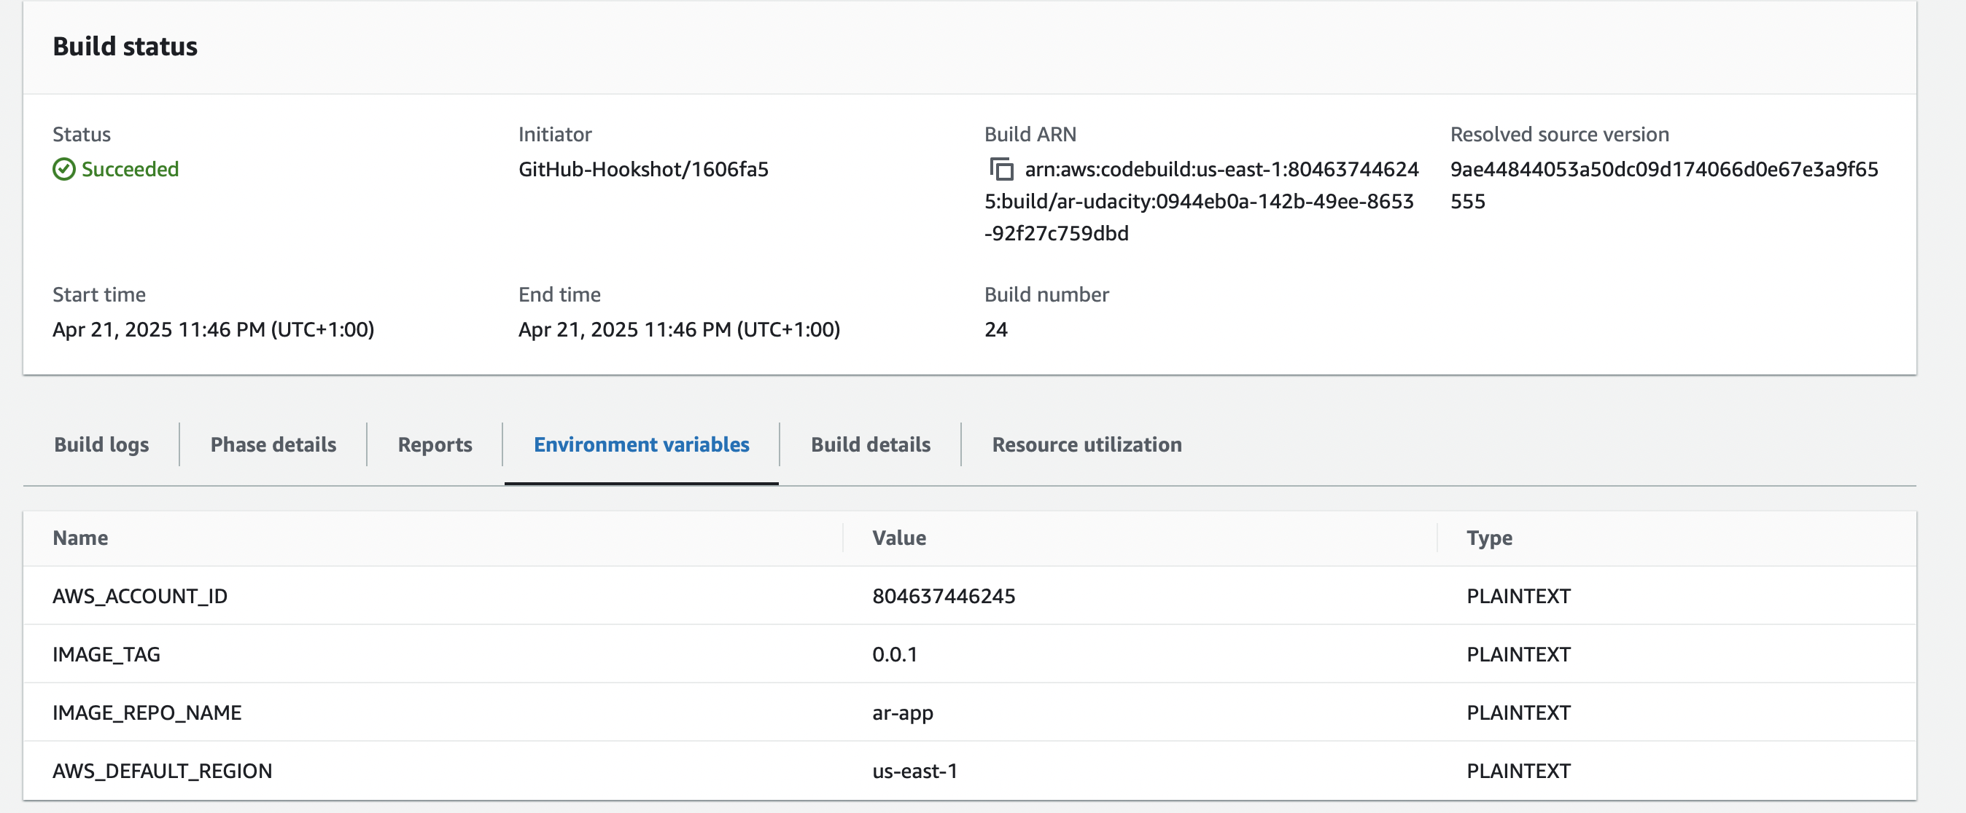

Kubernetes services



Kubernetes get pods

Kubectl describes service postgresql

Describe deployment

Kubectl logs

Cloudwatch logs

